ARMY ORIENTEERING ASSOCIATION
Coaching Officer
Building 25
Longmoor Camp
LISS, GU33 6EL

Tel of Bldg 25:Mil: 94291 3419 Civ: 01420 483419
Mobile: 07733047634
E-mail: coaching@armyorienteering.com

See Distribution | Reference:  Date: | AOA/Courses/Inters  03 Oct 16

ARMY ORIENTEERING ASSOCIATION INTERMEDIATE SKILLS COURSE –
JOINING INSTRUCTIONS

General
- The Army Orienteering Association (AOA) orienteering Intermediate skills course will take place at Longmoor Training Area near Liss, Hampshire as advertised (see course dates on http://www.baoc.info/events).
- Pre-course training and course aim
- This is a progression from the Basic Skills course which must have been completed before applying for this course. In exceptional circumstances the Coaching Officer may waive this.
- All students must have completed MATT 5 – Land Navigation in the 12 months prior to the course start date.
3. The aim of the Inter Skills is to progress, learn new skills and to advance up the British Orienteering step system so that by the end of the course they can successfully complete a TD5 orienteering course.
4. A detailed course programme and training objectives will be provided on day 1 of the course.
Course places
- Courses places are bid through the AOA Coaching Officer and are allocated on a first come first served basis. Course place applications are to be made using the form at Annex B. Civilians are welcome and should contact the undersigned in the first instance.
Cancellations
6. Personnel granted places are to notify the coaching officer as soon as possible if they are unable to attend the course.
Reporting
7. Students are to report to Building 25 in Longmoor Camp before 0930hrs on the first day of the course (Monday) to carry out course joining administration. Students will be booked in and allocated their accommodation, and attend a briefing before the course starts. Dress is sports kit.

Dispersal
8. The course will disperse at 1700hrs on the final day of the course (Thursday) after the closing address in the Aldershot area.
Administration
9. Accommodation. Students are to inform the coaching officer if accommodation is not required. The accommodation provided at Longmoor Camp is basic training camp type accommodation with limited facilities. There is limited bedding available at Longmoor, therefore all students are required to bring sleeping bags. Accommodation rooms can be locked and some lockers are available, individual padlocks are to be brought if required. Laundry and additional shower facilities are available within the camp in Bldg 15.
10. Accommodation on Sun Evening. Students who require accommodation on Sun evening are to inform the Coaching Officer at least 5 working days in advance. There is no messing available on Sun eve.
- Messing. All meals are provided by the central catering facility at Longmoor. Meal timings are as follows:
Breakfast - 0700 - 0800hrs
Lunch - Packed meal daily to allow flexibility in teaching.
Evening Meal - 1730 - 1800hrs
- Travel arrangements. Longmoor Camp is situated on the A3, 30 mins from Guildford and 45 mins from Portsmouth. Details and maps are at Annex A. Students arriving by car are to report to the Guardroom with photo identity where they will be issued with a pass and then directed to Building 25. Parking is in official parking areas only. The nearest railway station to Longmoor is Liss. Students arriving by train should use a taxi to get to Longmoor and claim the journey cost on JPA on return to unit.
- Security. Students are to comply with all local security requirements and are to remain vigilant. Personnel are responsible for all their own kit, equipment and valuables brought to Longmoor.
- Pets. Dogs and other pets are not permitted on Longmoor Training Camp or Area.
- Postal address and telephone number. The details for the AOA Building at Longmoor Camp is:
Number, Rank, Name
AOA Building 25
Longmoor Camp
LISS
GU33 6EL

Tel: Mil 94291 3419 Civ 01420 483419. Note – This building is only manned during course dates.

Dress and equipment
- Uniform is not required on the course. Sufficient sports clothing and equipment suitable for orienteering including outer clothing suitable for wet weather should be brought to the course. While some lessons will take place in the classroom, much of the course will be conducted on the training area. The following equipment is also required:
Item | Qty | Remarks
Waterproof clothing | As required | For outdoor activity and suitable for carrying out physical activity
Orienteering shoes | 2 pairs | Or trainers suitable for off road conditions
Orienteering suits | 2 | Or running t-shirts and long bottoms for leg protection.
Day sack | 1 | Take dry kit to area
Plastic bags | As required | For wet clothes
Water bottle | 1
Flask | 1
Knife, fork and spoon | 1 set | Cookhouse doesn’t always provide these
Compass | 1 | Issued Silva compass is fine
Whistle | 1 | Mandatory for use on the training area if injured / lost
Sleeping bag | 1
Padlock and key | 1 | To secure personal equipment in the accommodation
Stationery | As required | As a minimum notebook, pens/pencils and red pens (biros or fine permanent pens)
Head torch | 1 | For night orienteering (Tue night)
Other torch | 1 | As back up for head torch

- Clean casual clothes or clean and presentable tracksuits may be worn at meal times.
Summary
- The AOA courses offer valuable skills to all students in order to improve their orienteering and navigation in general. Any queries regarding these joining instructions or the course should, in the first instance, be directed to the Coaching Officer.
Electronically Signed

Phill Batts
AOA Coaching Officer
coaching@armyorienteering.com
07733047634

Annexes:

A. Location Maps for Longmoor Camp
B. Course place application form

Distribution:
All students
Copy to:
AOA Sec
Asst Coaches

Annex A To
AOA/Courses/Inters
Dated 03 Oct 16
LOCATION MAPS OF LONGMOOR TRAINING AREA
Location of camp entrance is at (186) SU 79253105, post code GU33 6EL.
Electronic copies of this document contain the following active links to internet maps showing the location of the Camp Entrance: Google Maps Multimap Streetmap
Location of Building 25 and Main Square Parking
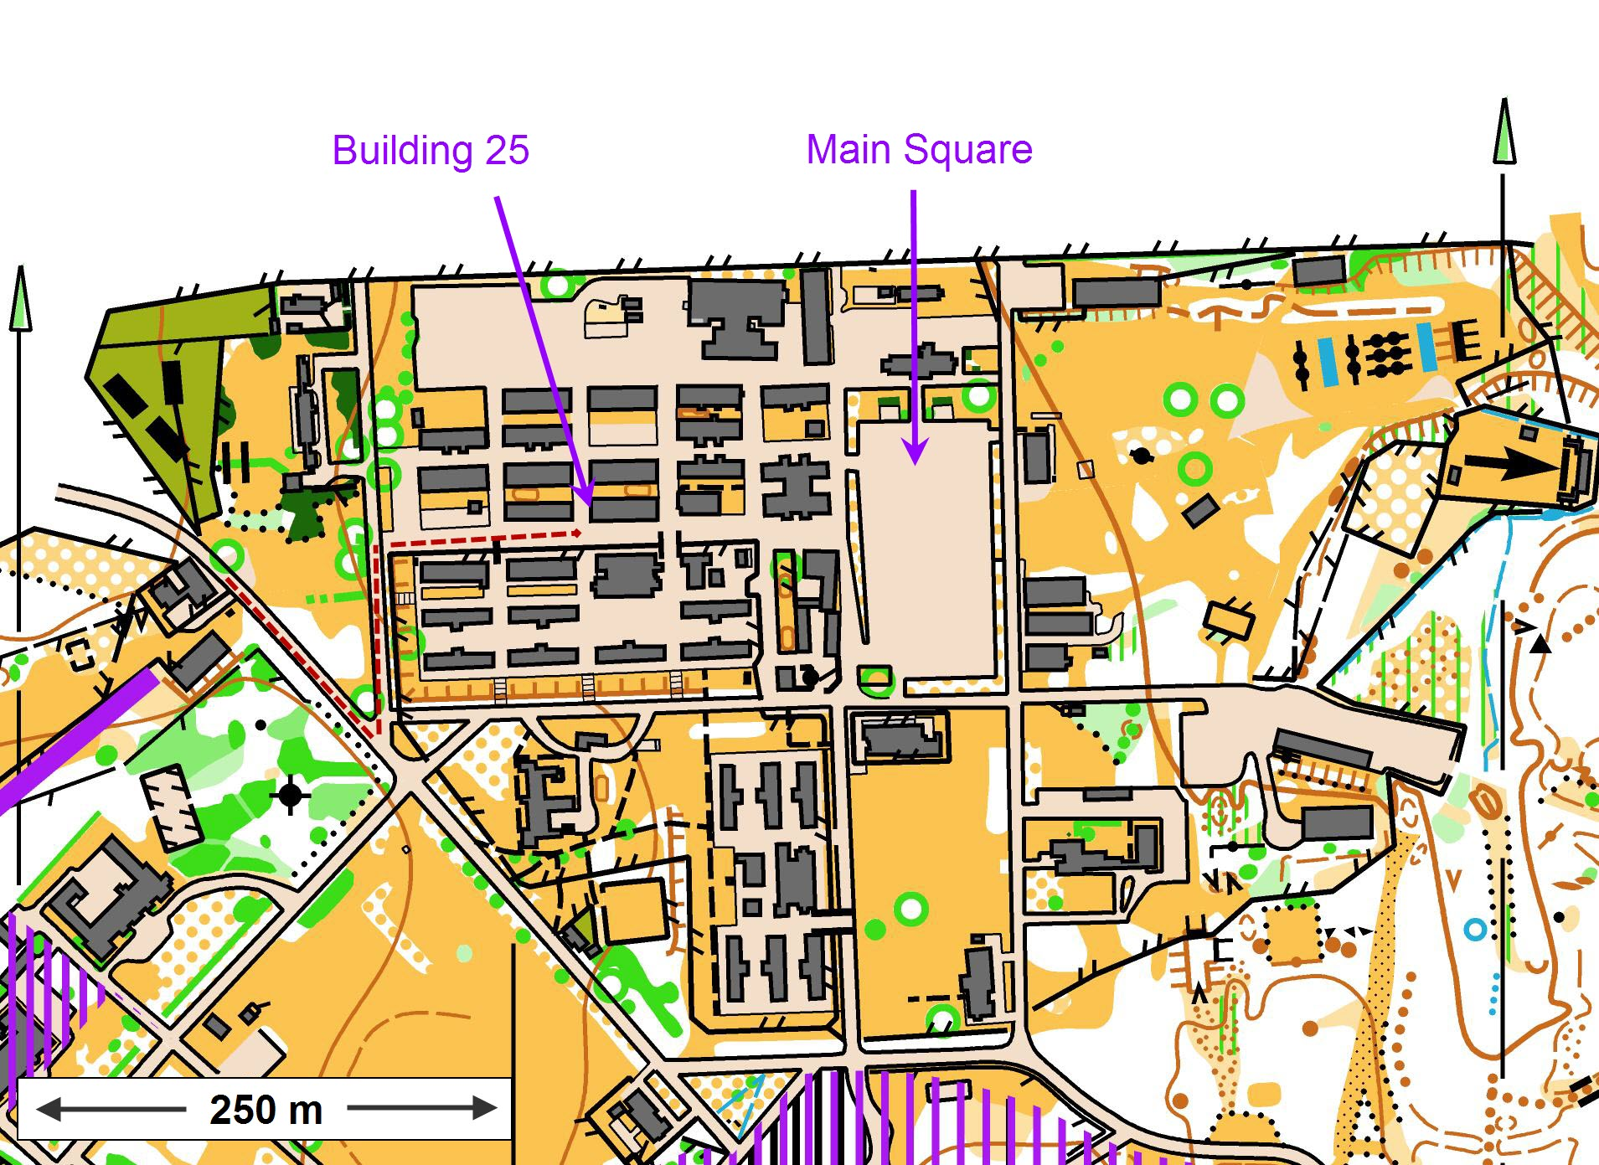

Annex B To
AOA/Courses/Inters
Dated 03 Oct 16
Army Orienteering Association Course Booking
Personal Details
Service Number |  | Rank |  |  | Surname
Known name |  |  | Gender
Unit |  |  | Corps
Course Name | Inters |  |  |  | Date
Dietary Requirements
Remarks
Date attended basic skills course
Relevant experience to assist loading on the above course.
(For intermediate skills please give details your last/best 5 events)
Date | Event | Result

Return This form to coaching@armyorienteering.com

